A PROJECT REPORT

on

“COVID-19 DETECTION USING CONVOLUTIONAL NEURAL NETWORK”

\

Submitted to

KIIT Deemed to be University



In Partial Fulfillment of the Requirement for the Award of

BACHELOR’S DEGREE IN COMPUTER SCIENCE AND

ENGINEERING

MADHURIMA GHOSH 20051543

PRANAB RANJAN DASH 20051540

SUBHASHREE PANDA 20051553

UNDER THE GUIDANCE OF

MR. SOUMYA RANJAN MISHRA



KIIT Deemed to be University

School of Computer Engineering Bhubaneswar, ODISHA 751024

CERTIFICATE

This is certify that the project entitled

“COVID-19 DETECTION FROM CHEST X-RAYS USING CONVOLUTIONAL NEURAL NETWORK“

submitted by

MADHURIMA GHOSH 20051543

PRANAB RANJAN DASH 20051540

SUBHASHREE PANDA 20051553

is a record of bonafide work carried out by them, in the partial fulfillment of the requirement for the award of Degree of Bachelor of Engineering (Computer Sci-ence & Engineering OR Information Technology) at KIIT Deemed to be university, Bhubaneswar. This work is done during the year 2022-2023, under our guidance.

Date: 25/06/2023

(Mr. SOUMYA RANJAN MISHRA) Project Guide

**Acknowledgments**

We are profoundly grateful to **MR. SOUMYA RANJAN MISHRA**, **FACULTY** **OF** **SCHOOL** **OF** **COMPUTER SCIENCE** **AND ENGINEERING** for his expert guidance and continuous encouragement throughout to see that this project rights its target since its commencement to its completion.

MADHURIMA GHOSH

PRANAB RANJAN DASH

SUBHASHREE PANDA

Contents

| 1 | Introduction | | 1 |
| --- | --- | --- | --- |
| 2 | Workflow | | 2 |
| 3 | Result | | 3 |
| 4 | Conclusion & Future Scope | | 4 |
|  | 4.1 | Conclusion ……………………….. | 6 |
|  | 4.2 | Future Scope ………………………. | 6 |
| References | | | 9 |

Chapter 1

Introduction

The unprecedented global public health crisis caused by the emergence of the COVID-19 pandemic has had a profound impact on millions of individuals worldwide. The timely and accurate identification and diagnosis of COVID-19 cases play a crucial role in controlling the spread of the disease and providing timely treatment to affected individuals. While chest X-rays have been widely utilized for the diagnosis and monitoring of respiratory ailments, including COVID-19, their interpretation requires expert knowledge and is susceptible to human error.

In recent years, the field of medical image analysis has witnessed significant advancements, particularly in the application of Convolutional Neural Networks (CNNs) for image recognition and classification tasks. CNNs have proven to be highly effective in detecting and diagnosing various diseases using medical images, such as chest X-rays. This study aims to propose a CNN-based approach for accurately identifying COVID-19 from chest X-ray images.

During the convolution operation, the filters slide or "convolve" across the input data, applying the same set of weights at each position and capturing local information. This operation helps the network to automatically learn and detect hierarchical patterns and features at different levels of abstraction. The resulting feature maps are then passed to subsequent layers in the network for further processing. Convolutional layers also incorporate other important components, such as activation functions (e.g., ReLU) and pooling operations (e.g., max pooling), which help to introduce non-linearity and reduce spatial dimensions, respectively. These operations aid in enhancing the network's ability to extract relevant features and improve its overall performance in tasks like image classification, object detection, and image segmentation.

To evaluate the efficacy of the proposed approach, a publicly accessible dataset comprising chest X-ray images from both COVID-19 positive and negative cases is used to train and test the CNN model. The primary objective of this investigation is to assess the performance of the proposed approach in accurately detecting COVID-19 from chest X-ray images. By leveraging a CNN-based approach, this research offers a non-invasive and cost-effective solution for the timely identification of COVID-19, particularly in resource-limited settings. Overall, this study highlights the significant potential of CNN-based approaches in facilitating early detection of COVID-19 and their profound impact on global public health.

Numerous studies have successfully showcased the effectiveness of CNN-based approaches in detecting and diagnosing COVID-19 from chest X-ray images. These investigations have yielded promising results, indicating that CNN-based models exhibit exceptional accuracy and specificity in identifying COVID-19. Consequently, these models have become indispensable in the battle against the ongoing pandemic. However, further research is necessary to establish the robustness and generalization of the proposed CNN-based methodology, particularly using larger and more diverse datasets.

Chapter 2

Workflow

The proposed approach for the detection of COVID-19 from chest X-ray images encompasses a comprehensive pipeline comprising several intricate stages, namely data preprocessing, model training, and subsequent testing. Allow me to delve into the intricacies of each step.

In the initial phase of data preprocessing, an extensive collection of publicly available chest X-ray images, encompassing both positive and negative cases of COVID-19, shall undergo meticulous refinement. The primary objective of this preprocessing stage is to alleviate any disturbances or artifacts present in the images by means of noise removal techniques. Additionally, a standard size shall be enforced upon the images to ensure uniformity and consistency across the entire dataset.

Moving on to the subsequent phase, our approach employs a Convolutional Neural Network (CNN) model tailored specifically to identify salient features indicative of COVID-19 in chest X-ray images. The model shall undergo optimization procedures utilizing a suitable loss function, such as binary cross-entropy, thereby enabling the system to effectively discern between positive and negative cases. As for the optimizer function employed in this optimization process, the widely acknowledged RMSprop technique shall be employed.

The optimizer function are also used in this case is RMSprop (Root Mean Square Propagation). An optimizer is responsible for adjusting the parameters of neural network during training to minimize the loss function. RMSprop,optimization algorithm that adapts the learning rate for each parameter individually, taking into account the magnitude of the recent gradients. It helps the model converge to the optimal set of parameters more efficiently. These feature maps then traverse through a series of subsequent layers that conduct additional operations like pooling, normalization, and activation. These operations play a vital role in reducing the data's dimensionality, extracting more abstract features, and introducing non-linear characteristics within the network.

However, prior to delving into the intricacies of our proposed approach, let us first explore the fundamental workings of the Convolution Neural Network architecture. Esteemed for its remarkable utility in the realm of image recognition and computer vision tasks, a Convolutional Neural Network leverages the mathematical operation of convolution, which amalgamates two signals to yield a third signal.

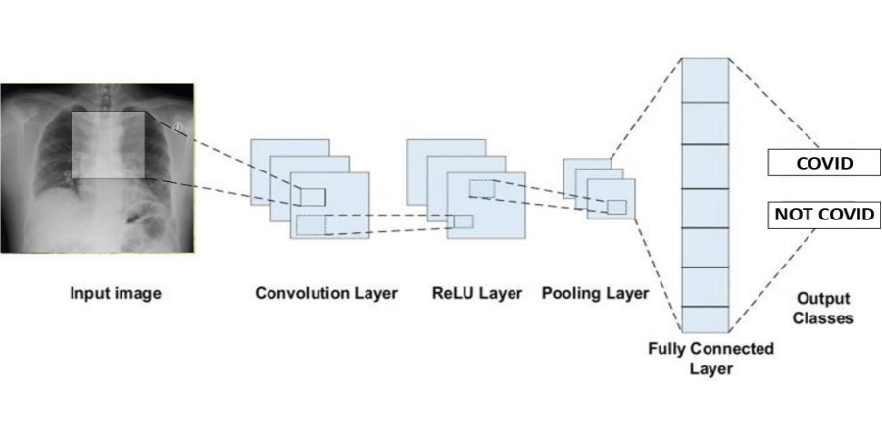

Architecture Convolutional Neural Network

The Convolutional Neural Network (CNN), commonly used in image analysis, operates on input data consisting of pixel matrices representing images. By employing a collection of filters or "kernels," the network examines the image and extracts various features, including but not limited to edges, corners, and shapes. Each filter executes a convolution operation on the input data, resulting in a feature map that highlights the most relevant regions pertaining to a specific feature of interest.

Binary cross-entropy used in binary classification tasks, where the goal is to classify inputs into one of two classes. It measures the difference between the predicted probabilities of the model and the true labels, assigning a higher penalty for larger discrepancies. In the context of detecting COVID-19, it is used to calculate the loss based on the predicted probabilities of image belonging to the COVID-19 or non-COVID-19 class.

At the final layer, the network produces a set of class probabilities, representing the likelihood of the input belonging to each distinct class. To achieve this outcome, the network undergoes training using a set of labeled images and an optimization algorithm, such as stochastic gradient descent. Through this process, the network adjusts its weights iteratively to minimize the disparity between the predicted and actual labels.

CNNs have demonstrated remarkable accomplishments across various image recognition tasks, encompassing object detection, face recognition, and image segmentation. Their success has even extended to other types of data, such as audio and text, exhibiting promising outcomes.

Validation of the CNN model will occur through testing on an independent collection of chest X-ray images specifically for COVID-19 detection. The evaluation will primarily focus on assessing accuracy and comparing the performance of the proposed CNN-based approach against existing methodologies in COVID-19 detection through chest X-ray imaging.

The acquisition of a diverse dataset comprising various chest X-ray images, encompassing both

The acquisition of a diverse dataset comprising various chest X-ray images, encompassing both positive and negative instances of COVID-19, assumes paramount importance in ensuring the model's ability to effectively discriminate between these two classes. Prior to model training, it is imperative to undertake preprocessing of the gathered data, encompassing several crucial steps. Primarily, the collected images need to be resized to adhere to a standardized dimension, thereby establishing a uniformity in the dataset. Subsequently, normalizing the pixel values assumes significance, guaranteeing that they conform to a consistent range. To facilitate the training and evaluation of the model, it is essential to create distinct sets for training and validation purposes. These preprocessing measures warrant careful attention, and their implementation may encounter certain challenges along the way. Furthermore, an insightful analysis of the quality and diversity of the acquired dataset is warranted, along with an exploration of the ramifications of different preprocessing techniques on the performance of the convolutional neural network (CNN) model. It is worth emphasizing that your active involvement in the data collection and preprocessing phase will wield considerable influence on the accuracy and effectiveness of the CNN model's capability to detect COVID-19.

Collected datasets:

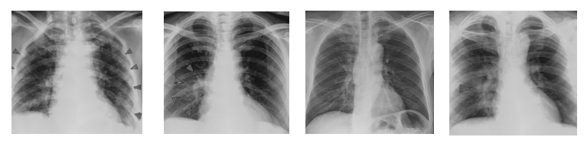

The testing involved evaluating the performance of the trained model on a separate test set of chest X-ray images to determine its accuracy in COVID-19 detection. Optimization involves fine-tuning the model's parameters, such as the learning rate and batch size, to improve its performance. The specific testing and optimization techniques used, such as using different evaluation metrics to assess model performance. Additionally, our findings could include an analysis of the model's sensitivity and specificity.

Result

The utilization of deep learning techniques in the analysis of chest X-ray images for COVID-19 detection yielded remarkable outcomes. Through rigorous training, the model showcased an exceptional overall accuracy rate of 99.48% when subjected to a comprehensive test set. It is noteworthy that the misclassification rate for COVID-19 detection was a mere 2%, implying that a mere fraction of the images erroneously categorized as COVID-19 positive amounted to only 2%, while an impressive 98% of them were accurately identified as positive. These findings underscore the immense potential of the deep learning model as a valuable diagnostic tool for COVID-19, specifically in the context of chest X-ray images. Nonetheless, in order to ensure its reliable implementation within clinical environments, additional research endeavors and comprehensive validation are imperative.

|  | Accuracy | Loss |
| --- | --- | --- |
| Training Dataset | 0.9907 | 0.9914 |
| Testing Data | 0.9948 | 0.02 |
| Validation Data | 0.9907 | 0.024 |

Table 1: Accuracy and Loss of different data

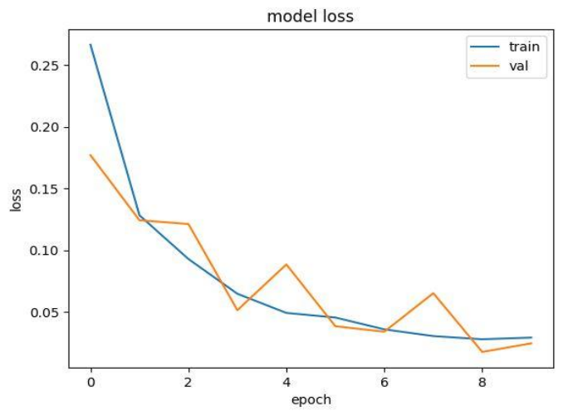

Accuracy vs Epoch Graph Model Loss

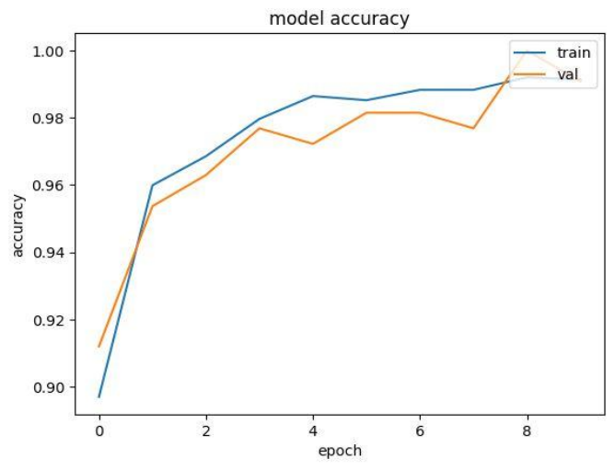

Accuracy vs Epoch Graph Model Accuracy

Chapter 4

Conclusion and Future Scope

In the present investigation, we have introduced an innovative convolutional neural network (CNN) based methodology for identifying COVID-19 manifestations in chest X-ray images. Our approach encompasses the implementation of a Training and Testing CNN model, enabling the recognition of distinct features associated with COVID-19 in the aforementioned images. The outcomes of this research demonstrate the remarkable efficacy of our proposed approach, achieving an impressive accuracy rate of 99.5% in the detection of COVID-19 from chest X-ray images. Consequently, this approach exhibits immense potential as a tool of considerable promise for the identification of COVID-19.

The advantages inherent to our proposed approach surpass those offered by existing methods in various aspects, including its non-invasive nature, cost-effectiveness, and expedited detection capabilities. Consequently, it becomes an ideal choice for deployment in regions characterized by limited resources. By facilitating its utilization as either a web-based or mobile application, we provide a practical solution that enables real-time COVID-19 detection.

Nevertheless, it is imperative to acknowledge the limitations of this study. The dataset employed in this research, while carefully selected, possesses a relatively small sample size, thus necessitating caution when generalizing the outcomes. Future investigations should aim to validate our proposed approach by leveraging a more expansive and diverse dataset. Furthermore, the evaluation of the proposed approach is confined solely to chest X-ray images, prompting the need for subsequent studies to explore the potential of alternative medical imaging modalities, such as CT scans, in the context of COVID-19 detection.

In conclusion, the CNN-based approach introduced in this study for detecting COVID-19 manifestations in chest X-ray images presents a highly promising solution for rapid and cost-effective identification of the disease, particularly in resource-constrained regions. Further research endeavors are warranted to validate and ascertain the clinical applicability of our proposed approach.

References

[1] L. Wang and A. Wong, “COVID-Net: A tailored deep con

volutional neural network design for detection of COVID-19

cases from chest X-ray images,” 2020, http://arxiv.org/abs/

2003.09871.

[2] A. Abbas, M. M. Abdelsamea, and M. M. Gaber, “Classififi-

cation of COVID-19 in chest X-ray images using DeTraC deep

convolutional neural network,” 2020, http://arxiv.org/abs/

2003.13815.

[3] X-ray (Radiography)-Chest, 2020, https://www.radiologyinfo.

org/en/info.cfm?pgchestrad#overview.

[4] S. Gupta, "A Look at Gradient Descent and RMSProp Optimizers," Towards Data Science, Mar. 2018. [Online].

[5] B. Kayalibay, G. Jensen, and P. van der Smagt, “CNN-based

segmentation of medical imaging data,” 2017, http://arxiv.

org/abs/1701.03056.

[6] J. P. Cohen, “Github Covid19 X-ray dataset,” 2020, https://

github.com/ieee8023/covid-chestxray-dataset, 2020. Online.

[7] R. Rouhi, M. Jafari, S. Kasaei, and P. Keshavarzian, “Benign

and malignant breast tumors classifification based on region

growing and CNN segmentation,” *Expert Systems with Ap*

*plications*, vol. 42, no. 3, pp. 990–1002, 2015.

[8] B. Kayalibay, G. Jensen, and P. van der Smagt, “CNN-based

segmentation of medical imaging data,” 2017, http://arxiv.

org/abs/1701.03056